Project Planning Phase
Project Planning Template (Product Backlog, Sprint Planning, Stories, Story points)

Date | 23 June 2025
Team ID | LTVIP2025TMID39799
Project Name | Cleantech: Transforming Waste Management With Transfer Learning
Maximum Marks | 5 Marks

Product Backlog, Sprint Schedule, and Estimation (4 Marks)
Use the below template to create product backlog and sprint schedule
Sprint | Functional Requirement (Epic) | User Story Number | User Story / Task | Story Points | Priority | Team Members
Sprint-1 | Dataset Setup & Preprocessing | USN-1 | As a developer, I want to load and explore the dataset so I can understand its structure and requirements. | 2 | High | Kasa Roshini
Sprint-1 | Dataset Setup & Preprocessing | USN-2 | As a developer, I want to apply image preprocessing and augmentation to improve model performance. | 3 | High | Kasa Roshini
Sprint-2 | Model Building with Transfer Learning | USN-3 | As a developer, I want to fine-tune a pre-trained CNN (ResNet50/VGG16) on the WBC dataset. | 5 | High | Kasa Roshini
Sprint-1 | Model Evaluation | USN-4 | As a developer, I want to evaluate the model using test data and visualize the confusion matrix. | 3 | High | Kasa Roshini
Sprint-3 | Web App Development | USN-5 | As a user, I want to upload a blood cell image and receive a classification result. | 4 | Medium | Kasa Roshini
Sprint-3 | Web App Development | USN-6 | As a user, I want the interface to show prediction probability and WBC type for interpretability. | 2 | Medium | Kasa Roshini
Sprint-4 | Final Testing and Deployment | USN-7 | As a developer, I want to test the model on unseen data to verify its robustness. | 3 | High | Kasa Roshini
Sprint-4 | Final Testing and Deployment | USN-8 | As a developer, I want to deploy the Flask app for public demonstration and testing. | 2 | Medium | Kasa Roshini

Project Tracker, Velocity & Burndown Chart: (4 Marks)
Sprint | Total Story Points | Duration | Sprint Start Date | Sprint End Date (Planned) | Story Points Completed (as on Planned End Date) | Sprint Release Date (Actual)
Sprint-1 | 5 | 5 Days | 01 July 2025 | 5 July 2025 | TBD | TBD
Sprint-2 | 8 | 5 Days | 6 July 2025 | 10 July 2025 | TBD | TBD
Sprint-3 | 6 | 5 Days | 11 July 2925 | 15 July 2025 | TBD | TBD
Sprint-4 | 5 | 5 Days | 16 July 2025 | 20 July 2025 | TBD | TBD

Velocity:
Imagine we have a 10-day sprint duration, and the velocity of the team is 20 (points per sprint). Let’s calculate the team’s average velocity (AV) per iteration unit (story points per day)
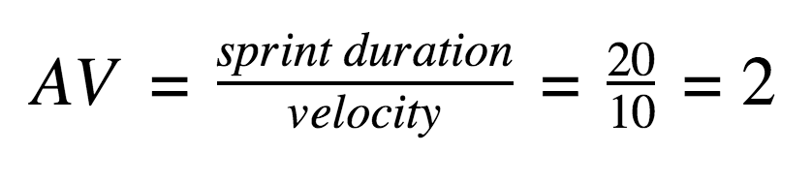

Burndown Chart:
A burn down chart is a graphical representation of work left to do versus time. It is often used in agile software development methodologies such as Scrum. However, burn down charts can be applied to any project containing measurable progress over time.

https://www.visual-paradigm.com/scrum/scrum-burndown-chart/
https://www.atlassian.com/agile/tutorials/burndown-charts

Reference:
https://www.atlassian.com/agile/project-management
https://www.atlassian.com/agile/tutorials/how-to-do-scrum-with-jira-software
https://www.atlassian.com/agile/tutorials/epics
https://www.atlassian.com/agile/tutorials/sprints
https://www.atlassian.com/agile/project-management/estimation
https://www.atlassian.com/agile/tutorials/burndown-charts

